**DHT11 HUMIDITY SENSOR WITH ARDUINO UNO**

**Description:**

The DHT11 is a basic, ultra-low-cost digital temperature and humidity sensor. It uses a capacitive humidity sensor and a thermistor to measure the surrounding air, and spits out a digital signal on the data pin (no analog input pins needed). It’s fairly simple to use, but requires careful timing to grab data. There are two pins on to the humidity sensor one is for ground and other for out which goes on the pin 2 on to Arduino.

**Circuit Diagram:**

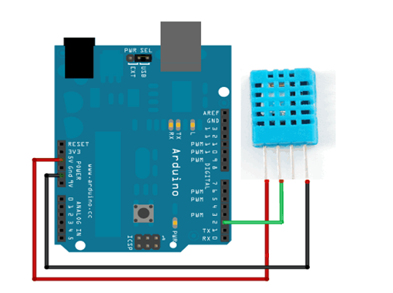

**Components Required:**

* Arduino Uno
* Humidity Sensor(DHT11)
* Connecting Wires

**Library Required:**

* DHT sensor library

(For more details refer http://playground.arduino.cc/Main/DHT11Lib)

**Specifications (DHT11):**

* Low cost
* 3 to 5V power and I/O
* 2.5mA max current use during conversion (while requesting data)
* Good for 20-80% humidity readings with 5% accuracy
* Good for 0-50°C temperature readings ±2°C accuracy
* No more than 1 Hz sampling rate (once every second)
* Body size 15.5mm x 12mm x 5.5mm
* 4 pins with 0.1" spacing

**Code:**

#include "DHT.h"

#define DHTPIN 2 // what pin we're connected to

#define DHTTYPE DHT11 // define type of sensor DHT 11

DHT dht (DHTPIN, DHTTYPE);

void setup()

{

Serial.begin(9600);

Serial.println("DHTxx test!");

dht.begin();

}

void loop()

{

delay(2000);

float h = dht.readHumidity();

float t = dht.readTemperature();

float f = dht.readTemperature(true);

if (isnan(h) || isnan(t) || isnan(f))

{

Serial.println("Failed to read from DHT sensor!");

return;

}

Serial.print("Humidity: ");

Serial.print(h);

Serial.print(" %\t");

Serial.print("Temperature: ");

Serial.print(t);

Serial.println(" *C ");

}

**Output:**

